TC-DISP-010
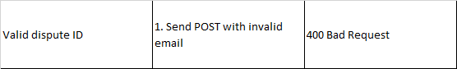
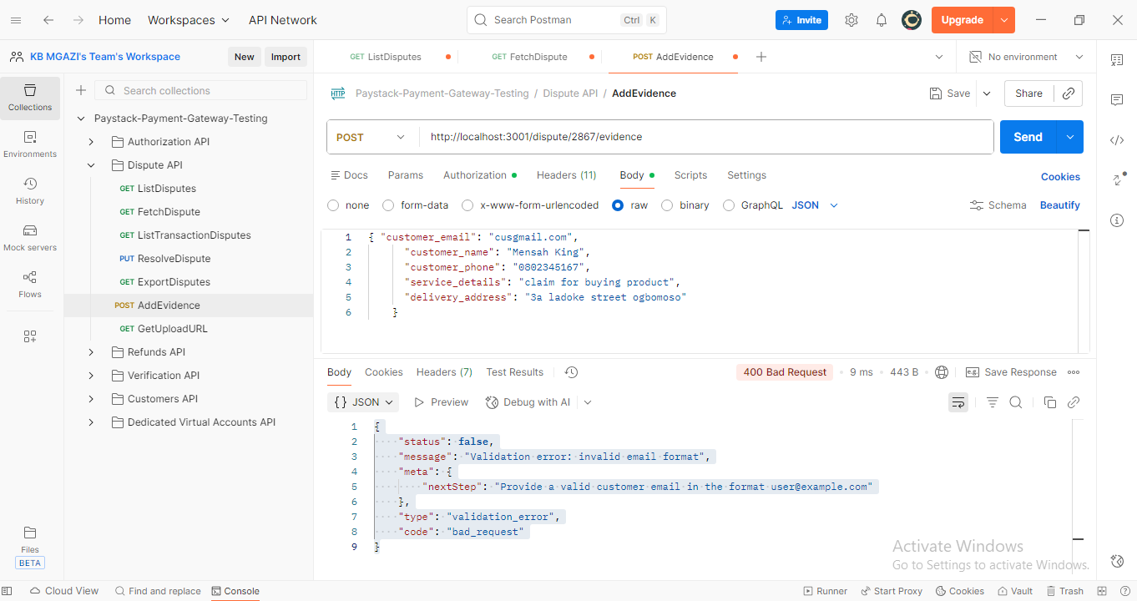
Request:
{ "customer_email": "cusgmail.com",
"customer_name": "Mensah King",
"customer_phone": "0802345167",
"service_details": "claim for buying product",
"delivery_address": "3a ladoke street ogbomoso"
}

Response:
{
"status": false,
"message": "Validation error: invalid email format",
"meta": {
"nextStep": "Provide a valid customer email in the format user@example.com"
},
"type": "validation_error",
"code": "bad_request"
}

